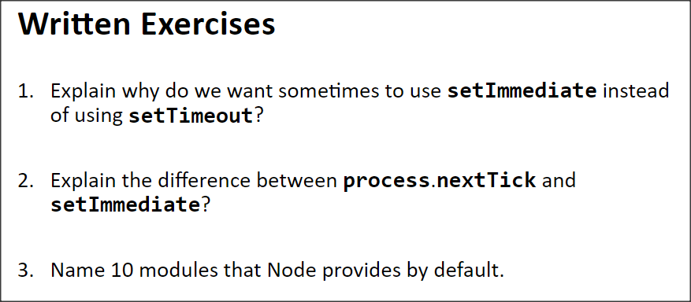

**Answers:**

1. It depends on the needs of the application. Sometimes we need to run something immediately after the current operation completes, then we use setImmediate. Sometimes we need to delay until particular interval of time before running something, which in this scenario we use setTimeout
2. Difference:

process.nextTick is not part of the event loop, while setImmediate is part of the event loop.

The call back of process.nextTick is registered in a priority queue “nextTick” queue.

Node processes all the callbacks in the nextTick queue after current operation completes and before the event loop continues, which means it runs before any additional I/O events or timers fire in subsequent tick of the event loop.

SetImmediate will schedule a callback to run at check phase of the event loop after I/O events’ callbacks.

1. 10 modules:
   1. http
   2. https
   3. net
   4. os
   5. path
   6. timers
   7. tls
   8. url
   9. util
   10. v8